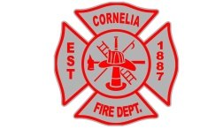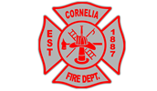

City of Cornelia
$50.00 Certificate of Occupancy Application
INSTRUCTIONS: Please fill in ALL information requested below and return to Cornelia City Hall
PLEASE BE ADVISED: NO APPLICATION WILL BE EXCEPTED WITH INCOMPLETE INFORMATION
City of Cornelia *Post Office Box 785* 181 Larkin Street Cornelia, Ga. 30531
Phone Number: (706)778-8585 Fax Number: (706)778-2234
Before a Certificate of Occupancy can be issued, the signature of the Cornelia Fire Marshal is Required.
To schedule an appointment for inspection, call Josh Hazle, Fire Marshal at (706)778-8585 Ext:284 or (706)949-8837 48Hours notice is required for inspections

Business Name:

Property Owner(s) Name(s):

Property Owner(s) Address and Telephone #:

Business Owner(s) Name(s):

Business Owner(s) Email:

Managing Agent(s) Name(s):

Business Type:

Physical Location of Business (Correct “911” Address):

Mailing Address of Business:

Phone Number at Business:

Square Footage to be occupied by business:

Nature of Business:

Does the space to be occupied by your business have a Fire Suppression System? YES or NO (Circle One)
Fire Marshal’s Signature:
Building Official’s Signature (New Construction):_________________________________________________
Emergency Numbers: Please provide contact numbers of “Key-Holder” to be reached anytime, day, or night, in case of an emergency. This is important information that will be entered into the Habersham County 911 Center database for emergency purposes to protect you and your business. Applicant should list the following information. Name and Relation to the business owner (Self, friend, manager, employee, parents, etc.) and contact numbers.
Example
John Smith, Manager Contact:1
(706)555-1234 (Home Phone) Contact:2
(706)555-4321 (Cellphone Contact:3

