Electrical System Diagram

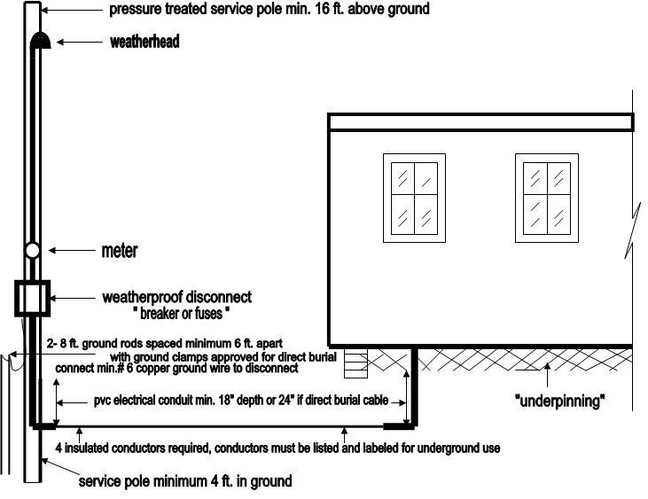

Disconnect  size in amps |  | Size of copper service wire | Size of conduit |  | Size of aluminum service wire | Size of conduit | Size of ground wire
100 |  | #4 | 1 ¼ “ |  | #2 | 1 ¼ “ | #6
150 |  | #1 | 2” |  | 2/0 | 2” | #6
200 |  | 2/0 | 2” |  | 4/0 | 2” | #4

