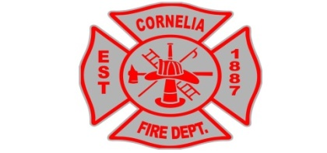
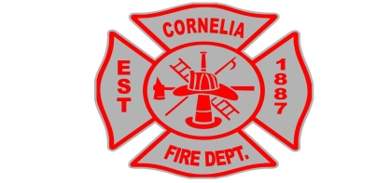
City of Cornelia Fire Department
Attn: Fire Marshal
P.O. Box 785
Cornelia, GA 30531
Phone: 706-778-8585 Ext284

LOCK BOX ORDER FORM
Please remit $25.00 payment to City Hall to purchase a small lock box from us.
Boxes can also be purchased at knoxbox.com
Please complete and return to City Hall.

Business Name:

Business Location Address:

Business Mailing Address:

Business Phone:

Business Type: Retail Service Manufacturing Other (If other, please explain)

Hours of Operation:

Owner(s) Name(s) Phone:
Phone:

Do you own the building?: Yes No If you answer no, please list the building owner below.

Building Owner: Phone: Address: Alternate Phone: In an emergency, contact persons in this order:

First Contact
Name:___________________________ Phone:_________________________

Second Contact
Name:___________________________ Phone:_________________________

Third Contact
Name:___________________________ Phone:_________________________

Alarm System: Yes No Alarm Audible: Yes No Auto Dialer: Yes No

Alarm Panel Location:

Is your alarm system monitored by a central station?: Yes No

Alarm Company Name:
Phone:

Alarm Types: Burglar Hold Up Panic Fire Medical

Does the building have a standpipe/sprinkler system?: Yes No

If yes, please specify the location of the Fire Department Connection:

Roof Type:
Stories:
Square Feet:

Elevator: Yes NO Elevator Manufacturer:

SPECIAL HAZARDS/ADDITIONAL INFORMATION
(Please include any hazardous materials or notes that may be pertinent about your business/building ie: guard dog, hazardous chemicals, etc.)

Owners Signature:
Date:

NOTE: All this information is confidential and stored at the Fire Station. This information is not accessible to anyone other than our public safety employees and is used for emergency purposes only.

