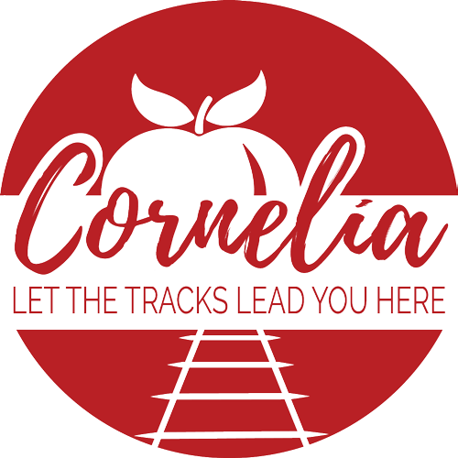

Agenda
City of Cornelia Commission Meeting
May 4, 2021

Invocation and Pledge of Allegiance

Call to Order

- Approval of the Agenda
- Minutes from the April 6, 2021 Commission Meeting Tab A
- Minutes from the April 17, 2021 Planning Retreat Tab B
- Community Development Monthly Report Tab C
- City Manager Monthly Report
- Public Forum (Comments Limited to 3 Minutes)

Old Business
- None

Public Hearings
- None

Consent Agenda
- None

New Business
- Automatic Aid Agreement with Baldwin for Fire Dept. Tab D
- GMA Lease Agreement for Public Safety Vehicles Tab E
- Bids for Level Grove Sidewalk Project Phase 2 Tab F
- Bids to Repair Hazel Creek Pump Tab G
- Proposal from Carl Vinson for Downtown Master Plan
- Executive Session for Litigation
- Adjourn

