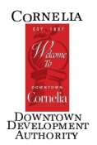
DDA/Main Street Board Meeting
AGENDA
Thursday, February 4, 2015 8:30AM
Cornelia Depot

- Meeting called to order

- Adopt Agenda

- Financials

- Old Business

- 2016 Work Plan
- Update on Assault on Mount Currahee
- Casino Night- Progress on Sponsors and ticket sales
- Update on Awards Ceremony

- New Business
- City Manager Update
- Economic Development grant money- Jan Garrison
- Bingo Night- weekly----\ These two may go hand-in-hand
- Advertising Fund--------/

- Upcoming Events: Annual Awards Ceremony 2/12/2016; Assault on Mount Currahee 2/27/2016

- Next Regular Board Meeting: 8:30AM Thursday, March 3, 2016 at the depot.

- Adjourn

