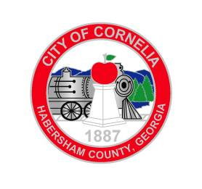
Agenda
City of Cornelia Commission Meeting
July 12, 2016

Call to Order

- Approval of the Agenda
- Approval of the June 7, 2016 Commission Meeting Minutes Tab A
- Approval of the June 21, 2016 Commission Meeting Minutes Tab B
- Public Forum (All comments will be limited to 3 minutes)
- Community Development Monthly Report Tab C

Old Business
- Ordinance # 06-16-01, Conditional Use Request for Cash Street School Tab D
- Ordinance # 06-16-02, Amendment to Growler Ordinance Tab E

Public Hearings
- None

Consent Agenda
- City Manager’s Monthly Report
- Resolution Assuring Compliance with National Flood Insurance Program Tab F
- Purchase of 2017 Ford F350 Pickup Tab G

New Business
- Award of Zoning Ordinance Update Project Tab H
- Incentives to Help Attract New Businesses to Downtown Tab I
- Ordinance # 07-16-01, Flood Damage Prevention Ordinance Tab J
- Executive Session for Real Estate
- Adjourn

