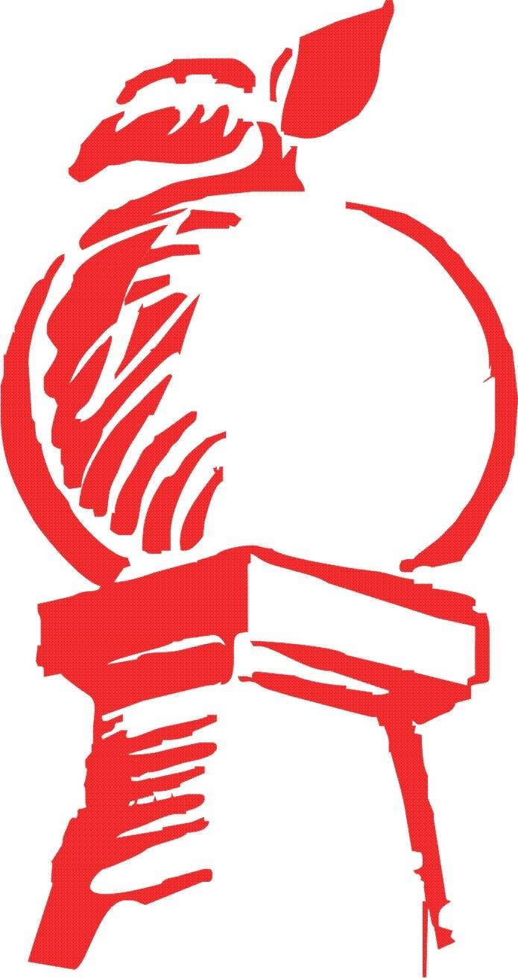

Agenda
City of Cornelia Water & Sewerage Authority Meeting
July 27, 2021

Call to Order

New Business
- Approval of the Minutes from April 27, 2021
- Engineer Update on Water & Sewer Projects
- Utilities Director Quarterly Report
- Adjourn

