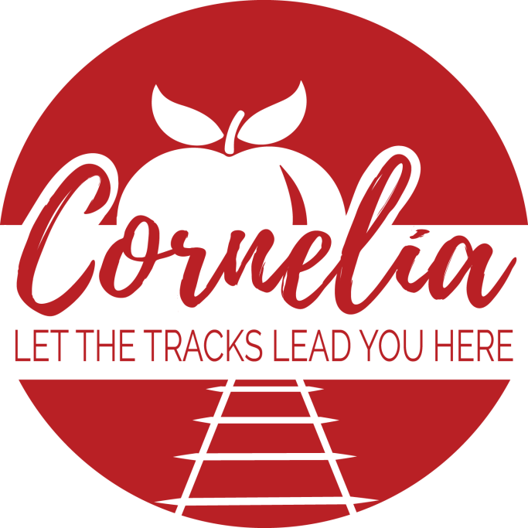

City of Cornelia
Office of Downtown Development

2023 Partnership Packet

Thank you!

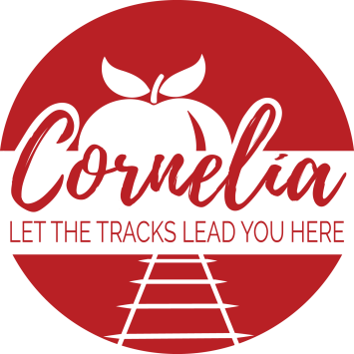

Dear Community Members,

It’s time to put 2022 behind us and move forward hoping for a great 2023! Our Main Street Manager, Noah Hamil has some creative and fresh ideas to bring to our event schedule this year. We have a great year planned for the city and need community support and involvement to build and grow these events. Don’t miss your chance to be part of the excitement and partner with the Cornelia Downtown Development Authority & the Cornelia Hospitality & Tourism board in hosting the following great events.
You can now donate directly to our Sign/Façade Grant fund! This grant fund helps give back to our downtown businesses by encouraging business owners to improve the aesthetic of their space either by renovating the outside or getting new signage. When the facades of our businesses look good, people are more inclined to go inside. Also, if the town is aesthetically pleasing, it lets people know that we take pride in our community and encourages new businesses to come in! Please consider adding a donation to our grant fund so that the DDA can keep the momentum going!

Façade/Sign Revitalization Fund- Ongoing
The Revitalization Fund helps business owners pay for improvements to their facades or signs and makes the whole community more appealing. This grant fund is a key operation of the DDA, which has proven to be a fantastic and much needed opportunity in Downtown Cornelia. Please consider donating to this fund for the betterment of our entire community.

Sign grant- Business owners get up to $500 reimbursement for a new sign $500

Façade grant- Business owners receive up to $1,500 reimbursement for
improvements to the façade of the building $1,500
Sign/Façade- Business owners can receive both a sign and façade grant in the
same fiscal year $2,000
Annual Donation- Sponsors may choose to donate to the Revitalization fund
on an annual basis. Just check this box and we will send
an invoice at the beginning of every year!

Events Sponsorships
We try to host events from small to extra-large. We also try to host events that cater to all ages and walks of life. Some event sponsorships are smaller. Some are much bigger. You have the option to sponsor each individual event if you choose, and this allows you to sponsor events that tailor to your budget! Just let us know your price range and we will customize the sponsorship to both fit your needs and benefit your business!

In-kind Sponsor- This is sponsorship in the form of gift certificates, gas cards, products, venue, etc.
- Mention on all social media platforms

Bronze Sponsorship- $500- These sponsorships help pay for marketing materials for events
- Listed as a sponsor on all print and digital marketing materials for specific event

Silver Sponsorship- $1,000- These sponsorships help pay for decorations, supplies, etc.
- Listed as a sponsor on all print and digital marketing materials for specific event
- Booth space at event specified

Gold Sponsorship- $2,000- These sponsorships help pay for marketing materials an entire area of an event. For example, entertainment, kids’ zone, or vendor fair, etc.
- Listed as a sponsor on all print and digital marketing materials for specific event
- Banners hanging to promote business in event area stated
- Booth space in prime location at event specified

All- Inclusive Sponsorship- $2,000- These sponsorships are the gift that keeps on giving. Business is listed for every event held throughout the year
- Listed as 2023 Program Partner on all marketing and media including social for all events held throughout the year.
- Banners hanging during events to promote your business

Presenting Sponsorship- $2,500-
These sponsorships are limited to one per event/festival. It helps pay for all aspects of the event and receives more marketing and advertising benefits than any other sponsor
- Partners will be listed as presenting sponsor on all marketing materials for specific event
- Mentions in radio, print ads, videos, and press releases
- Banners hanging to promote business throughout event
- Booth space in prime location at specified event
- Listing on apparel where applicable (t-shirts)
- VIP tickets and privileges for events where applicable

Please check or circle which option you’d like and fill out the contact information and return it,
along with funds, made payable to:
City of Cornelia, Attn: Jessie Owensby, P.O. Box 785, Cornelia, GA 30531

Please state which sponsorship you’d like. If individual event, please specify:

Value:

Name/Company Name as you would like it to appear in advertisements:

(Email logo file to nhamil@corneliageorgia.org )

Contact Person:

Address:
Phone No: ( ) -

Email Address:

Website:

All of our events aim to bring a diverse group of people, representing a wide variety of ages, to Cornelia & Habersham County from all over the Southeast to promote tourism in our area.
Please look over the attached information pertaining to each event and pick what suits your business/organization the best. Please return your completed form(s) and payment made payable to the City of Cornelia as soon as possible so that we can include you on all promotion of events. (All donations are tax deductible as allowed by Georgia Law.)
Please contact us for additional information or to discuss a customized sponsorship package. We look forward to working with you this year.

Noah Hamil- Main Street Manager
nhamil@cornelia.city
706-778-8585 ext. 209

Jessie Owensby- Community Development Director
dmanager@cornelia.city
706-778-8585 ext. 280

