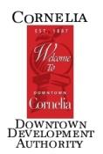
Historical Preservation Commission Meeting
AGENDA
Thursday, January 19, 2023 3:30 PM
Downstairs Commissioner’s Conference Room

- Meeting called to order:
  - New year round up
  - Downtown businesses

Present:

Absent:

Guest:

