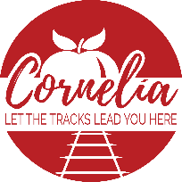
Cornelia Historic Preservation Commission

Thursday, March 16, 2023 3:30 p.m.
Downstairs Administrative Conference Room

- Meeting called to order by Perry Rettig, seconded by Don Higgins, approved by all
- Approval of agenda: Motion made by Perry Rettig, seconded by Shawn Knight, approved by all
- New Business
  - COA Application- Casey Martin- 1043 S Main St, Cornelia Ga.
    - New colors (Building, trim, door), sign, shutters (Must be wood but can be painted)
    - Need to check guidelines, if shutters need to be of original building or original era
    - Motion made to approve application to go forward by Gay Davis, seconded by Don Higgins, approved by all (Check on shutters, amend application after finding results)
- Old Business
  - Glass work repairs and updates- Borrowed and Blue
    - Found glass contractor- Matt Corals
    - Fix to original windows, remove rollout windows
    - Waiting on plans from Matt
  - Food factory
    - Space for dining outside
    - Back door entrance
    - Replace windows, but not use glass panels as they are not practical

- Next Regular Board Meeting: Thursday, April 23 at the Downstairs Administrative Conference Room at 3:30 p.m.

- Adjourn- Motion made by Don Higgins, seconded by Shawn Knight, Approved by all

Present: Perry Rettig, Jessie Owensby, Noah Hamil, Gay Davis, Shawn Knight, Don Higgins

Absent: Emily Herrin

