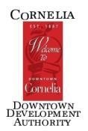
DDA/Main Street Board Meeting AGENDA
Thursday, May 4, 2023 8:30 AM
City Hall: Downstairs Commissioner’s Conference Room

- Meeting called to order:
- Financials:
- Operating-
- Façade-
- Savings-
- Old Business
  - Updates- Cornelia Music Festival
  - Updates- Farmer’s Market
  - Updates- Summer Nights
  - Chalk walk?
  - Murals? Renderings? Metal sign?

- New Business
  - Beautification- Google doc w/ public works
  - Programming- Anything need discussion?

- Next Board Meeting- Thursday, June 1 at the Downstairs Commissioner’s Conference Room

- Adjourn-

Present:

Absent:

Guests:

